SIMATS ENGINEERING (SAVEETHA SCHOOL OF ENGINEERING) Department of Computer Science and Engineering
ASSESSMENT TOOL 2 – Industry Problem Solving Task
Course Code: | CSA06 | Course Title: | Design and Analysis of Algorithms
CO Assessed: | CO4: Articulation (BL4, BL5) | Assessment: | Assessment Tool 2 – Industry Problem Solving Task
Weightage: | 20% of CIA | Total Marks: | 100
CO4 Statement: | Solve optimization problems using dynamic programming and greedy strategies.
Student Name: | S.MYTHILI | Reg. No.: | 192411250
Section / Batch: |  | Date: | 14/08/26

Instructions to Students
• Answer the following question. Total Marks: 100.
• Carefully analyze the given questions.
• Explain in detail with sample code if needed.
• Clearly identify all key issues.
• Provide a thorough analysis with validated results and performance evaluation.

Question Type | Focus Area | Questions
Industry Problem  Solving Task | Focus on Solving optimization problems using dynamic programming and greedy strategies | Q1

SECTION A – Industry Problem Solving Task
Code of Conduct
I __________________________ (Name / Reg No) certify that this submission is my original work and that I have adhered to the guidelines specified for this assessment. I understand that any violation of academic integrity rules will result in disciplinary action.
Signature of the Student: _________________________

RUBRICS FOR CALCULATION
Industry Problem Solving Task
Criteria | Weightage | Level 4 – Exemplary | Level 3 –  Proficient | Level 2 –  Developing | Level 1 –  Beginning
Understanding of Industry Problem | 20% | Comprehensive  understanding of  real-world problem and constraints | Good  understanding with minor gaps in  requirements | Basic  understanding;  some  requirements  unclear | Poor  understanding;  misinterprets  problem context
Application of  Engineering  Concepts | 25% | Applies advanced  and relevant concepts effectively to solve the problem | Applies  appropriate  concepts with  minor errors | Limited  application of  concepts | Incorrect or no  application of  concepts
Solution Design | 25% | Innovative, practical, and feasible solution aligned with industry standards | Logical and  feasible solution  with minor gaps | Basic solution  with limited  feasibility | Unclear or  impractical  solution
Use of Tools | 15% | Effective use of  modern tools,  technologies, and real data | Appropriate use of tools with correct implementation | Limited or  inconsistent use of tools | Minimal or  incorrect use of  tools
Analysis | 10% | Thorough analysis with validated results and performance  evaluation | Good analysis with reasonable  validation | Basic analysis  with limited  validation | Poor or no  analysis
Professionalism | 5% | Highly professional, well-documented,  and clearly presented work | Good  documentation and presentation | Basic  documentation  with some gaps | Poor  documentation  and presentation

Marks Evaluation:
Criteria | Wt. | Level 4 –  Exemplary | Level 3 –  Proficient | Level 2 –  Developing | Level 1 –  Beginning
Understanding of Industry Problem | 20%
Application of Engineering Concepts | 25%
Solution Design | 25%
Use of Tools | 15%
Analysis | 10%
Professionalism | 5%
Total Marks (100):

Faculty In-charge | Course Coordinator | Head of Department
Name: | Name: | Name:
Signature: _______________ | Signature: _______________ | Signature: _______________
Date: ___________________ | Date: ___________________ | Date: ___________________

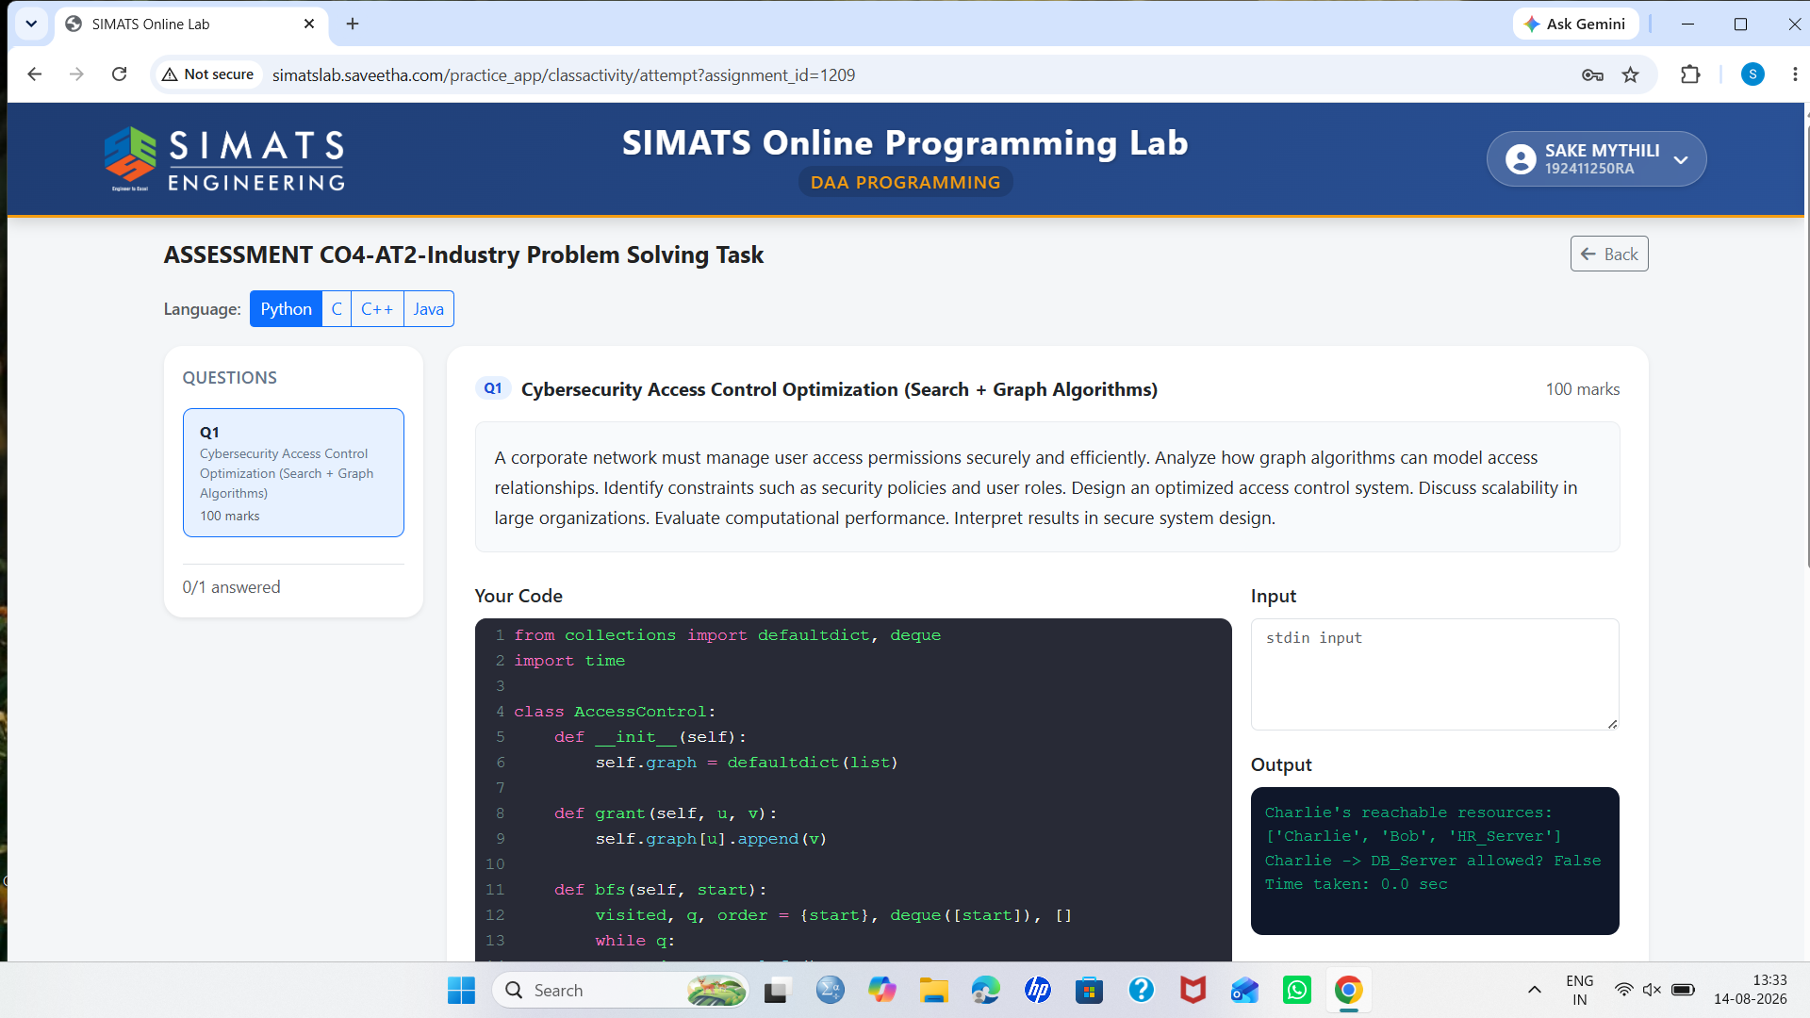

Cybersecurity Access Control Optimization (Search + Graph Algorithms)
1. Introduction
A corporate network contains many users, roles, applications, files, databases, and security policies. Managing access manually becomes difficult when the organization has thousands of users and resources. Graph algorithms can be used to represent and analyze these access relationships efficiently.
In an access-control graph, users, roles, resources, and permissions are represented as nodes, while relationships such as has-role, can-access, and inherits-permission are represented as edges. Search algorithms can then find valid access paths, while graph algorithms can detect unnecessary permissions, conflicts, and security risks.

2. Graph Model for Access Control
The access-control system can be represented using a directed graph:
G = (V, E)
Where:
- V = set of nodes such as users, roles, resources, and permissions.
- E = relationships between the nodes.
Example:
User → Role → Permission → Resource

Alice → Manager → Read → Database
Bob → Employee → Read → Reports
Admin → Administrator → Read/Write → Database
For example, if Alice belongs to the Manager role and the Manager role has permission to read a database, Alice can access the database through that relationship.

3. Access Control Relationships
The graph can contain different types of relationships:
- User → Role – represents role assignment.
- Role → Role – represents role inheritance.
- Role → Permission – represents permissions assigned to a role.
- Permission → Resource – represents access to a resource.
- User → Resource – represents direct access.
This model makes it easier to identify who can access which resource and why.

4. Search Algorithms
Search algorithms are used to efficiently find access relationships.
Breadth-First Search (BFS)
BFS explores the graph level by level. It can be used to find the shortest or simplest access path between a user and a resource.
Example:
User → Role → Permission → Resource
BFS can quickly determine whether a valid access path exists.
Depth-First Search (DFS)
DFS explores one path deeply before checking other paths. It can be useful for:
- Detecting role inheritance.
- Finding indirect permissions.
- Identifying circular role relationships.
- Analyzing complex access paths.

5. Security Constraints
The system must consider several security constraints.
a. Least Privilege
Users should receive only the permissions required to perform their jobs.
b. Role-Based Access
Permissions should preferably be assigned through roles instead of individually assigning permissions to every user.
c. Separation of Duties
Critical operations should require different users or roles. For example, the person who creates a financial transaction should not be the same person who approves it.
d. Security Policies
Access must follow organizational policies such as:
- Department restrictions.
- Resource classification.
- Time-based access.
- Location-based access.
- Multi-factor authentication requirements.
e. Deny Rules
Explicitly restricted resources must remain inaccessible even if another relationship appears to provide access.

